♜ |  | ♛ |  |  | ♜ | ♚
♟ | ♝ | ♟ | ♟ | ♞ |  | ♟ | ♟

How to Play Chess
  - From Chattahoochee Valley Libraries

A quick-and-easy guide for:
1. Setting up the board 1
2. Moving the pieces 2
3. Special moves 5
4. Check, checkmate, and stalemate 6
5. Draws: when no one wins 7
6. Chess lingo 8
7. Chess books at the library 10

1. Setting up the board
A game of chess has two players, one with “white” pieces and one with “black” pieces (although you may actually see them as green, blue, or any color). The chessboard is made of alternating dark and light squares, eight wide and eight long.
 | a | b | c | d | e | f | g | h
8 | ♜ | ♞ | ♝ | ♛ | ♚ | ♝ | ♞ | ♜ | 8
7 | ♟ | ♟ | ♟ | ♟ | ♟ | ♟ | ♟ | ♟ | 7
6 |  |  |  |  |  |  |  |  | 6
5 |  |  |  |  |  |  |  |  | 5
4 |  |  |  |  |  |  |  |  | 4
3 |  |  |  |  |  |  |  |  | 3
2 | ♙ | ♙ | ♙ | ♙ | ♙ | ♙ | ♙ | ♙ | 2
1 | ♖ | ♘ | ♗ | ♕ | ♔ | ♗ | ♘ | ♖ | 1
 | a | b | c | d | e | f | g | h
Begin the game by setting the board as shown above. Keep these details in mind:
- The lower-right square is light (“light on right”).
- The opposing kings face opposite to each other, and so do the opposing queens.
- The white queen goes on a light square, and the black queen goes on a dark square. (“Queen goes on her own color.”)

2. Moving the pieces
White always moves first. Then, the players take turns moving. A player cannot end their turn without moving.
Only one piece can move each turn, with the exception of “castling,” a special move. (Special moves are explained on page 5.)
Pieces cannot pass through other pieces, with the exception of moving the knight.
A player may not move a piece to a square occupied by one of their own pieces.

2.1 Capturing
To capture a piece, the player must move one of their pieces to the same square as their opponent’s piece. The captured piece is then removed from the game.

2.2 ♔ The king ♚
• | • | •
• | ♚ | •
• | • | •
 |  |  |  | • | • | •
 |  |  |  | • | ♔ | •
 |  |  |  | • | • | •
The king is the most important piece, but he is also weak. He can move one square in any direction: horizontal, vertical, or diagonal.
Make sure your king always stays safe!

2.3 ♕ The queen ♛
 |  |  | • |  |  |  | •
• |  |  | • |  |  | •
 | • |  | • |  | •
 |  | • | • | •
• | • | • | ♕ | • | • | • | •
 |  | • | • | •
 | • |  | • |  | •
• |  |  | • |  |  | •
The queen is the most powerful piece. She can move any number of squares in any direction: horizontal, vertical, or diagonal.

2.4 ♖ The rook ♜
 |  |  |  |  | •
 |  |  |  |  | •
 |  |  |  |  | •
• | • | • | • | • | ♜ | • | •
 |  |  |  |  | •
 |  |  |  |  | •
 |  |  |  |  | •
 |  |  |  |  | •
The rook is the second most powerful piece. It can move any number of squares vertically or horizontally, but not diagonally.

2.5 ♗ The bishop ♝
•
 | • |  |  |  |  |  | •
 |  | • |  |  |  | •
 |  |  | • |  | •
 |  |  |  | ♗
 |  |  | • |  | •
 |  | • |  |  |  | •
The bishop can move any number of squares diagonally.
Note that bishops can only move to the same color square that they started on. Each player has one light-square bishop and one dark-square bishop.

2.6 ♘ The knight ♞
 |  |  | • |  | •
 |  | • | ♟ | ♟ | ♟ | •
 |  |  |  | ♞
 |  | • |  |  |  | •
 |  |  | • |  | •
The knight doesn’t move like the other pieces. Instead of a straight line, it moves in an “L” shape. It will always move two squares horizontally or vertically, turn at a right angle, and finally move one more square. It is the only piece that can “hop” over other pieces.

2.7 ♟The pawn ♙
 |  |  |  |  | ♟
 |  |  |  | x | • | x
 |  | •
 | x | • | x
 |  | ♙
The pawn is the weakest piece. It can only move one square at a time, and it always moves straight ahead.
  - The dots mark where the pawns can move, and the Xs mark where they can capture.

Pawns are the only pieces that move differently to capture. They can only capture diagonally. If a piece is in the square in front of a pawn, then that pawn is blocked and cannot move.
When a pawn is still in its starting position, it has the option to move two squares instead of one.
If a pawn manages to reach the other end of the board (a difficult achievement!), then it gets “promoted” and becomes either a queen, a rook, a bishop, or a knight, but players almost always choose a queen.

3. Special moves

3.1 Castling
Each player has the option to “castle” once during a game. This is the only time when a player can move two pieces at once, the king and the rook.
The king moves two squares to the left or right towards a rook, and the rook “hops” over to the square on the other side of the king. Castling is only permitted if neither the king nor the rook has moved yet, and if there are no pieces between them.
A player may not castle out of check, into check, or through check. (Check and checkmate are explained on page 6).

 |  |  |  | ♚ |  |  | ♜
 |  |  |  | ♟ | ♟ | ♟ | ♟
♙ | ♙ | ♙ | ♙ | ♙
♖ |  |  |  | ♔
  - Before castling
 |  |  |  |  | ♜ | ♚
 |  |  |  | ♟ | ♟ | ♟ | ♟
♙ | ♙ | ♙ | ♙ | ♙
 |  | ♔ | ♖
  - After castling

3.2 En Passant
This is a French term for “in passing.” En passant may happen when one pawn moves two squares to avoid capture by an opponent’s pawn.
In this situation, the attacking pawn may still capture as if the first pawn had only moved one square.
This move is only an option on the turn immediately following the first pawn’s two-square move.

 |  |  |  | ↓
 |  |  |  | ↓
 |  |  | ♙ | ♟
 |  |  |  | ♙
 |  |  | ↗ | x

1. The black pawn advances two spaces
  - 2. The white pawn captures the black pawn as if the black pawn had only advanced one space.

4. Check, checkmate, and stalemate
♚ | ♕
 |  | ♘
 |  |  |  | ♔
The goal of chess is to “checkmate” your opponent, so learning how to checkmate is very important.
If a piece moves to where a king could be captured on the next move, then the king is in “check”.
When a player’s king is in check, then that player’s next move must get their king out of check. That could mean moving the king, capturing the attacking piece, or placing a piece between the king and the attacking piece.
  - The black king has been checkmated by the white queen. No matter where Black moves, they can’t escape check.
If there is no possible way out of check, then that is “checkmate,” and the game is over.
A player can never move their own king into check. This includes moving a piece that was previously blocking the king from check.

5. Draws: when no one wins
 | ♕
♚ |  | ♔
 |  | ♘
Several situations will end the game in a draw. Some are obvious, but others can confuse even seasoned players without a reliable reference.
Stalemate: When one player is not in check but has no legal move.
Insufficient material: The game is a draw if both sides do not have enough pieces (material) to checkmate. This occurs with the following combinations:
  - Black has no legal move, so this is a stalemate. (If it’s Black’s turn to move.)
- King against king.
- King against king and bishop.
- King against king and knight.
- King and bishop against king and bishop, with both bishops on squares of the same color.
Fifty-move rule: Players can agree to draw if there has been no capture or pawn move in the last fifty moves by each player.
Threefold repetition: Players can agree to draw if the same board position has occurred three times in a row.

6. Chess lingo
Attack: When one piece could capture another piece on its next turn.
Capture: The move in which a player takes a piece.
Control: All of the squares where a piece could capture.
Back Rank: The first and eighth ranks (see also: Rank).
Bad Bishop: When a bishop is blocked by its own pieces.
Blunder: A bad move.
Defense: When a piece can move and meet another piece’s attack.
Develop: To move pieces from their starting positions.
File: A column on a chessboard. They are labeled with letters A through H. For example, you would say that the kings start on the “E file.”
♚
♔
♞
♕
Fork: When a piece attacks two pieces at once. In this example, the black knight is forking the white king and white queen. White cannot save both pieces.
Gambit: Sacrificing a piece to gain a positional advantage.
God: A hypothetical player who plays perfectly, with a rating around 3600. (See also: Ratings.)
Index: When a player mentally makes note of every possible square where each piece could move.
Kingside: The half of the board where the kings start, files E through H.
Major Piece: A rook or a queen.
Material: The pieces. The player with more pieces has a “material advantage.”
Minor Piece: A knight or a bishop.
♛
♚
♞
♔
♖
Pin: When a piece is attacked but the player cannot move it because doing so would expose a more valuable piece to attack. In this example, the white rook is pinning the black knight.
Position: How the pieces are arranged on the board. A player with a better position has a “positional advantage.”
Queenside: The half of the board where the queens start, files A through D.
Rank: A row on a chessboard, labeled with numbers 1 through 8.
Ratings: Organizations such as USCF and FIDE use number ratings to rank players. A novice will be below 1200, and a grandmaster will be above 2500. Magnus Carlson, currently the world’s highest-rated player, is in the 2800s.
Tempo: Time, measured by moves. When a player makes a pointless move, they “lose tempo.”
Trade: When a player captures an opponent’s piece while letting their opponent capture one of their own pieces.
Zugzwang: When a player is forced to make a move when they would rather pass without moving.

7. Chess books at the library
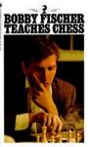  Bobby Fischer Teaches Chess  by Bobby Fisher | 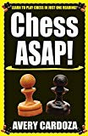  Chess ASAP!  by Avery Cardoza.
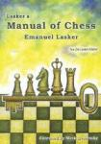  Lasker's Manual of Chess  by Emanuel Lasker | 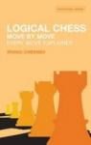  Logical Chess  by Irving Chernev
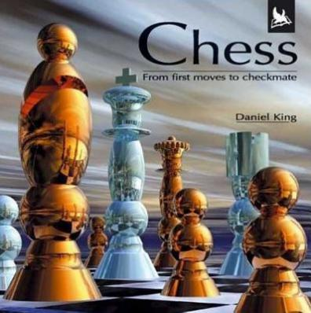  Chess : from first moves to checkmate  by Daniel King | 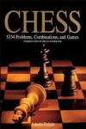  Chess: 5334 Problems, Combinations and Games  by László Polgár
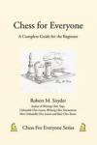  Chess for Everyone  by Robert M. Snyder. | 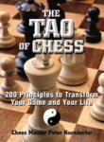  The Tao of Chess  by Peter Kurzdorfer.
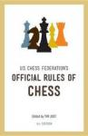  Official Rules of Chess  by United States Chess Federation | 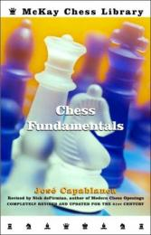  Chess Fundamentals  by José Capablanca

Chattahoochee Valley Libraries  3000 Macon Road  Columbus, GA 31906 | Phone: (706) 243-2669  Toll Free: 1-800-652-0782  www.cvlga.org

